**Exercise**

**Creating the pipeline**

**Exercise - Create the pipeline**

* 20 minutes

At this point, Mara has defined a build configuration for the *Space Game* website. Now it's your turn. You're going to create a pipeline and produce your first build artifact.

As you saw, Mara uses a YAML file to define the build. When you create a pipeline, the process prompts you for your YAML file. The project doesn't have this file yet.

When you don't provide an initial YAML file for your project, Azure Pipelines can create one for you based on your application type. Here, you build an ASP.NET Core application, but Azure Pipelines provides starter build configurations for other project types as well, including Java, Go, and more.

**Create the pipeline**

1. In Azure DevOps, go to your project.
2. Select **Pipelines**, either from the project page or from the left pane.
3. Select **Create Pipeline**.

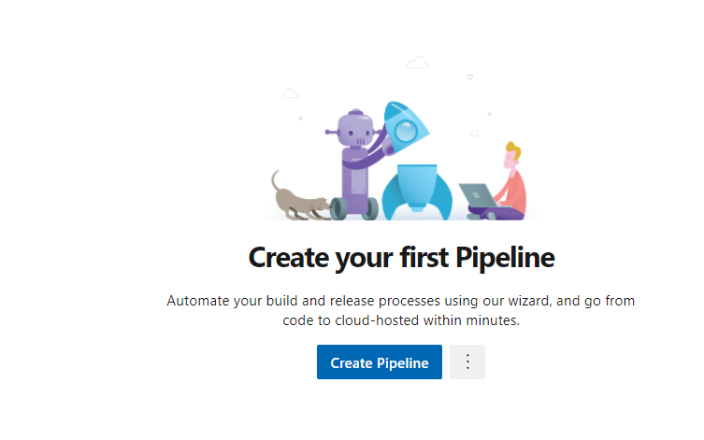

1. On the **Connect** tab, select **GitHub**.

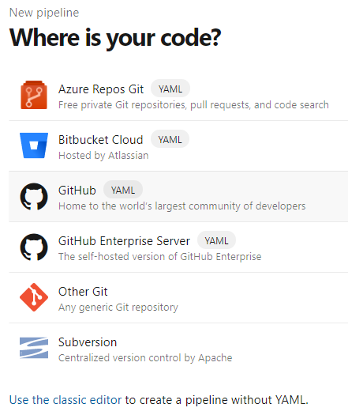

When prompted, enter your GitHub credentials.

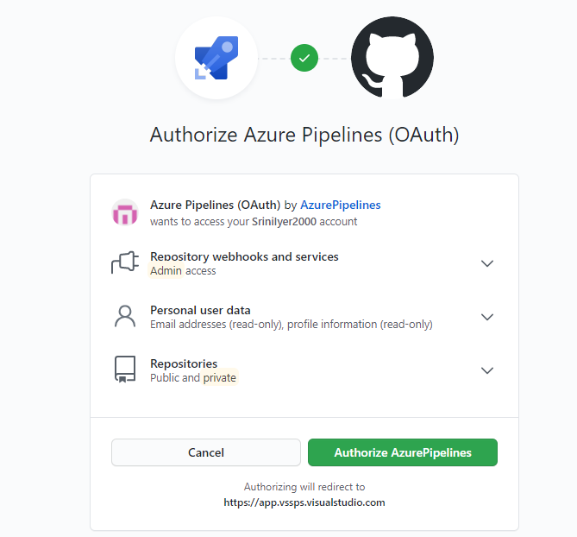

1. On the **Select** tab, select your **mslearn-tailspin-spacegame-web** repository.

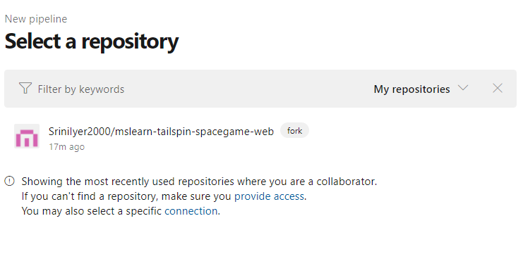

1. You might be redirected to GitHub to install the Azure Pipelines app. If so, scroll to the bottom and select **Approve and install**.

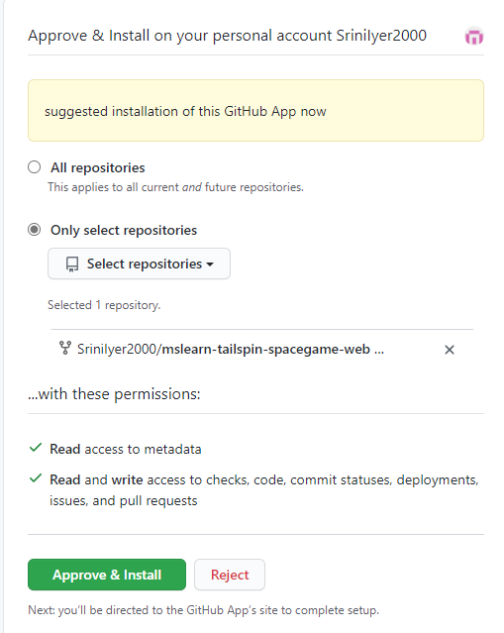

1. On the **Configure** tab, select **ASP.NET Core**.

**Note**

If you don't see this option, select **Show more**. Don't select **ASP.NET Core (.NET Framework)**.

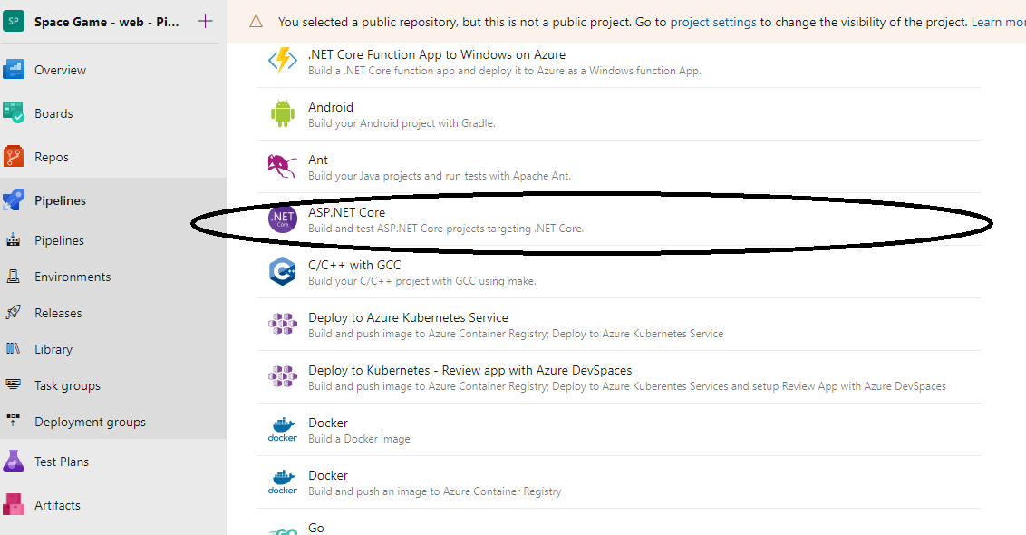

1. On the **Review** tab, note the initial build configuration.

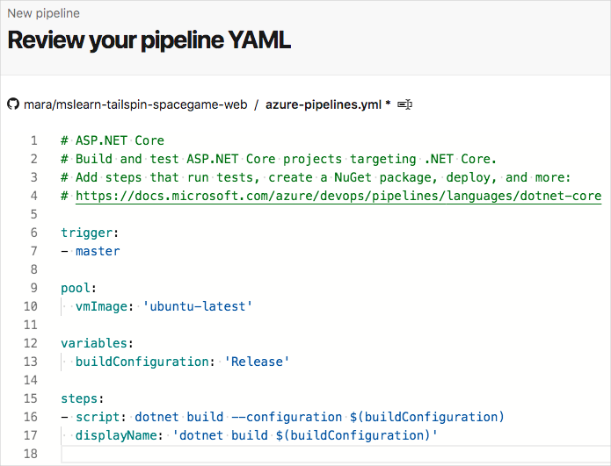

This is a very basic configuration that Azure DevOps provides for you based on your application type, ASP.NET Core.

1. On the **Review** tab, select **Save and run**. Then select **Save and run** a second time to commit your changes to GitHub and start the build.

**Watch the pipeline run**

Under **Jobs**, select **Job**. Then trace the build process through each of the steps. Optionally, when the build completes, select **View raw log** to see the job output as a text file.

Here you see the steps that the build definition created. It prepares the VM, fetches the latest source code from GitHub, and then builds the application.

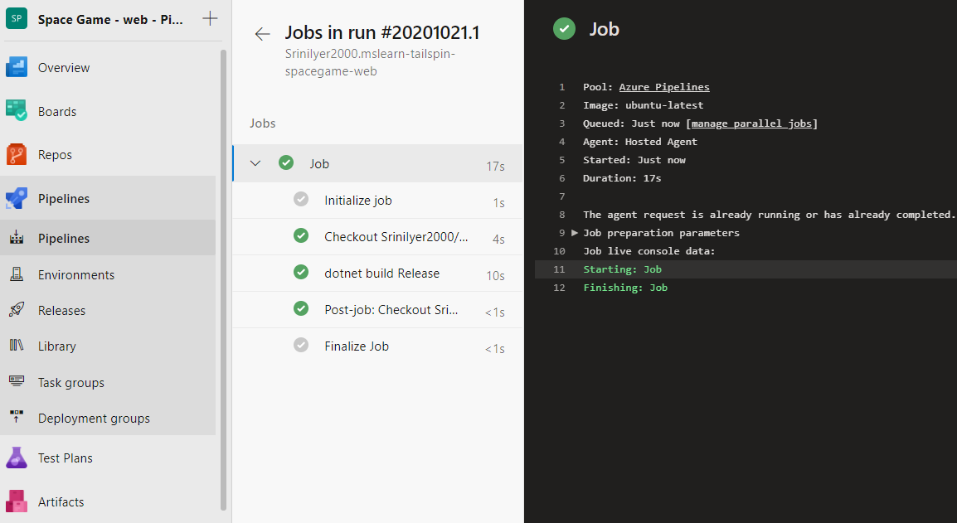

This configuration is a great start because now you have a place to add build tasks. However, it needs to be updated to meet the needs of the Tailspin team, such as to minify JavaScript and CSS files.

**Tip**

Check your email. You might have already received a build notification with the results of your run. You can use these notifications to let your team members know when builds complete and whether each build passed or failed.

**Add build tasks**

Now that you have a working build process, you can start to add build tasks.

Remember that you're working from the master branch. You'll now create a branch named build-pipeline to hold your work. The branch gives you a place to experiment and get your build working completely without affecting the rest of the team.

You can add build tasks to *azure-pipelines.yml* directly from Azure Pipelines. Azure Pipelines will commit your changes directly to your branch. But here you'll modify *azure-pipelines.yml* locally and push, or upload, your changes to GitHub. Doing it this way lets you practice your Git skills. Watch the pipeline automatically build the application when you push up changes.

In practice, you might add build tasks one at a time, push up your changes, and watch the build run. Here, you'll add all the build tasks we identified earlier at one time.

**Note**

You're about to run a few Git commands. Don't worry if you're new to Git. We'll show you what to do. We'll also go into more detail about Git in future modules.

1. In Visual Studio Code, go to the integrated terminal.
2. Run this git pull command to fetch the latest changes from GitHub and update your master branch.

**Bash**

**git pull origin master**

You see from the output that Git fetches a file named *azure-pipelines.yml*. This is the starter pipeline configuration that Azure Pipelines created for you. When you set up the pipeline, Azure Pipelines adds this file to your GitHub repository.

1. Run this git checkout command to create a branch named build-pipeline:

**Bash**

**git checkout -b build-pipeline**

1. In Visual Studio Code, modify *azure-pipelines.yml* as you see here:

trigger:

- '*'

pool:

vmImage: 'ubuntu-18.04'

demands:

- npm

variables:

buildConfiguration: 'Release'

steps:

- task: UseDotNet@2

displayName: 'Use .NET Core SDK 3.1.300'

inputs:

packageType: sdk

version: 3.1.300

- task: Npm@1

displayName: 'Run npm install'

inputs:

verbose: false

- script: './node_modules/.bin/node-sass Tailspin.SpaceGame.Web/wwwroot --output Tailspin.SpaceGame.Web/wwwroot'

displayName: 'Compile Sass assets'

- task: gulp@1

displayName: 'Run gulp tasks'

- script: 'echo "$(Build.DefinitionName), $(Build.BuildId), $(Build.BuildNumber)" > buildinfo.txt'

displayName: 'Write build info'

workingDirectory: Tailspin.SpaceGame.Web/wwwroot

- task: DotNetCoreCLI@2

displayName: 'Restore project dependencies'

inputs:

command: 'restore'

projects: '**/*.csproj'

- task: DotNetCoreCLI@2

displayName: 'Build the project - Release'

inputs:

command: 'build'

arguments: '--no-restore --configuration Release'

projects: '**/*.csproj'

The demands section beneath pool specifies that we need npm, the Node.js package manager, installed on the build system.

Under the steps section, you see the build tasks that maps to each of the script commands that we identified earlier.

Azure Pipelines provides built-in build tasks that map to many common build activities. For example, the DotNetCoreCLI@2 task maps to the dotnet command-line utility. The pipeline uses DotNetCoreCLI@2 two times: one time to restore, or install, the project's dependencies and one time to build the project.

Remember that not all build activities map to a built-in task. For example, there's no built-in task that runs the node-sass utility or writes build info to a text file. To run general system commands, you use the CmdLine@2 or script task. The pipeline uses the script task because it's a common shortcut for CmdLine@2.

In the build step that writes information about the build to a file, notice these elements:

* + $(Build.DefinitionName)
  + $(Build.BuildId)
  + $(Build.BuildNumber)

These elements are built-in variables that the system provides for use in your pipelines.

* + $(Build.DefinitionName) specifies the name of the build pipeline. For example, "SpaceGame-Web-CI."
  + $(Build.BuildId) is a numeric identifier for the completed build, like 115.
  + $(Build.BuildNumber) is name of the completed build. You can configure the format, but by default the build number includes the current date followed by the build number for that day. An example build number is "20190329.1."

You can also define your own variables, which you'll do soon.

You might have also noticed the UseDotNet@2 task, which is the first build step. Mara remembered that her build script didn't install required build tools. Although the build agent comes with a number of .NET Core SDK versions, this task lets her easily specify the version she needs to use on the build agent.

1. Run the following Git commands from the integrated terminal to add *azure-pipelines.yml* to the index, commit the change, and push the change up to GitHub. These steps are similar to steps you performed earlier.

**Tip**

Remember to save *azure-pipelines.yml* before you run these Git commands.

**Bash**

**git add azure-pipelines.yml**

**git commit -m "Add build tasks"**

**git push origin build-pipeline**

This time, you push the build-pipeline branch, not the master branch, to GitHub.

Pushing the branch to GitHub triggers the build process in Azure Pipelines.

1. In Azure Pipelines, go to your build. To do so, select **Pipelines** on the side of the page and then select your pipeline. You see your commit message and that the build is running using the code from the build-pipeline branch:

Azure Pipelines showing the latest build

**Tip**

If you don't see the build right away, wait a few moments or refresh the page.

1. Select your build and trace the build tasks as they run.

For example, here's what happens when the gulp@1 task runs to perform the gulp tasks that minify JavaScript and CSS assets:

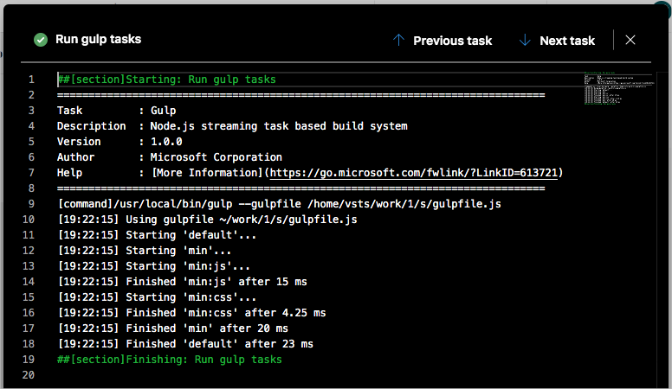

If any step fails, you'll see the error in the output so you can diagnose and repair the failure.

Earlier, you ran a more minimal build configuration. This time, when the build is completed, you see a more complete set of tasks needed to build the application:

1. After your build is completed, select any of the steps to see the overall progression of the build. From there, you can jump to the build logs or the associated change on GitHub.

Azure Pipelines showing the complete list of build tasks with one selected